# Summary

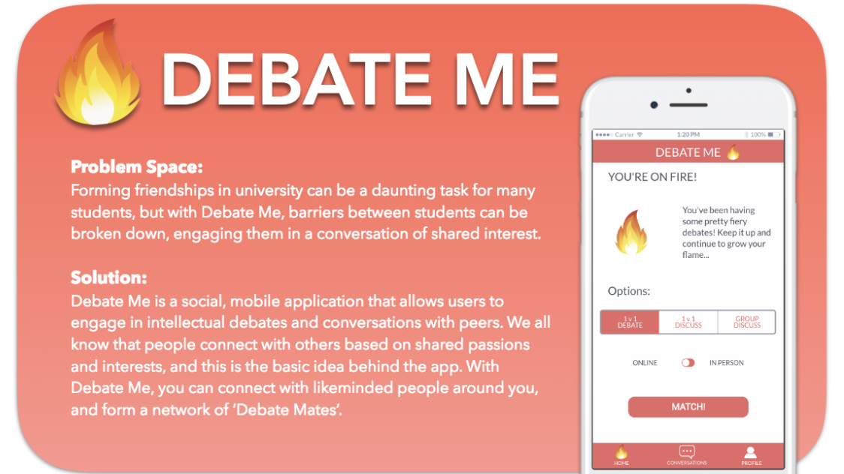

# Design Process

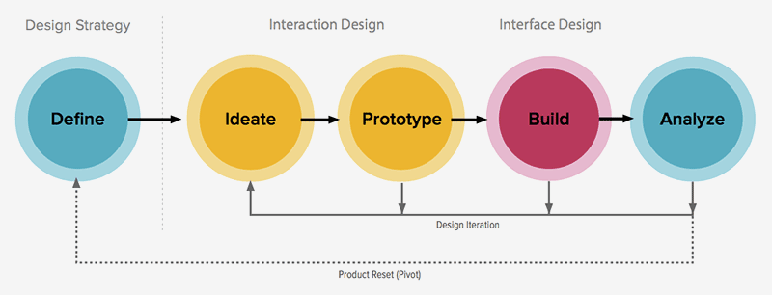

We followed the tradition design process throughout the semester, using Agile methodology. These phases included:

1. Define the problem which we addressed in the project proposal
2. Ideate meaning form a solution
3. Prototype by creating a low fidelity paper prototype as well as a high fidelity prototype using Marvel
4. Building the prototypes and user test plans
5. Analysing results from user tests
6. Repeating the process

As we followed Agile Methodology, user testing and evaluation was an iterative process and done through sprints. Several user tests needed to be taken throughout the semester to improve upon our ideas.

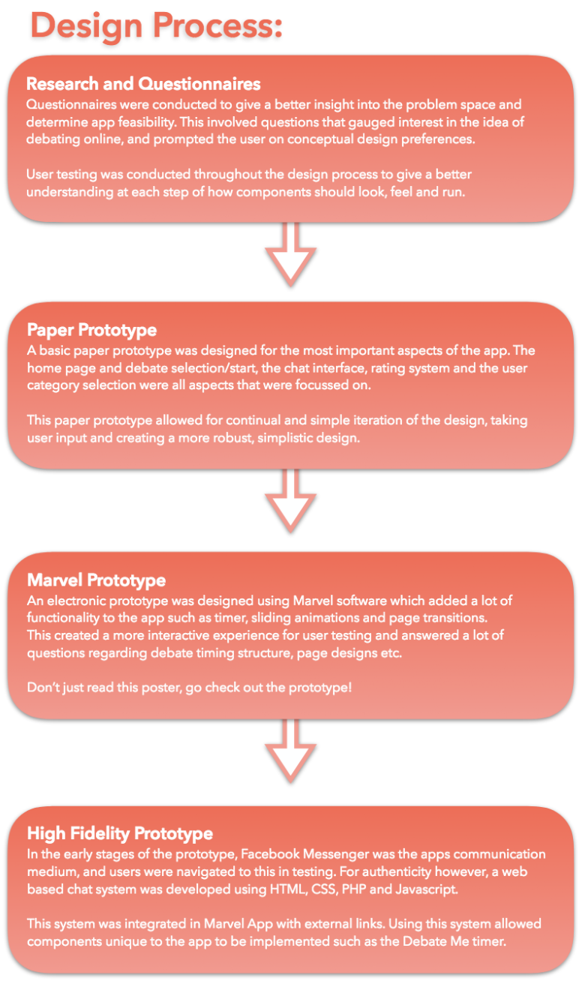

The above process showcases how we evolved our design throughout the semester. It was an iterative process with several iterations and design decisions.

**Examples of design decisions:**

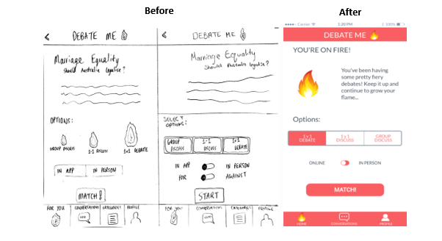

**Design decision of home screen:**

Initially we created two versions of the home screen for the paper prototypes. The paper prototype on the left which included flames which represented the difficulty of the debate, the bigger the flame the more difficult and challenging. The prototype on the left a very similar layout, however we removed the flames and included buttons instead. From the user tests, participants commented that for the first prototype the flames looked quite similar to Tinder thus, making feel like they were using Tinder. While another participant said that the size of the fire visual metaphor was unclear. For the second paper prototype, users liked the buttons instead of the flames, but however believed it was too clustered as the in app and in person buttons were too much. For the final decision of the home screen we decided to combine both paper prototypes together to make the final product, consisting of the basic buttons from prototype the first prototype. The online and in-person radio buttons included, while the for and against were removed, making the home screen more simple looking.

# **Capture868686.PNG**

# 

# **Design decision of matching screen:** For the matching of the users we added a brief overview on the topic. The position for/against will be assigned automatically which no longer can be chosen by the user. A timer of 2 minutes for users to prepare for their debate was also implemented. This was mainly due to the user test sessions, which we found users needed more time given to prepare.

# 

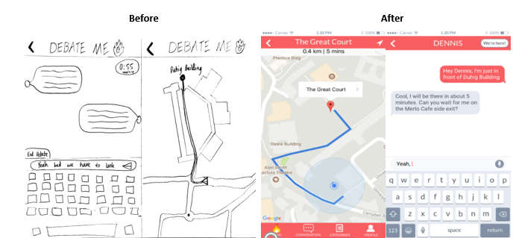

**Design decision of the in-person feature:**

Originally users would end a debate and had the opportunity to choose to meet up, as pictured on the left. But after conducting user's test. We made changes so that users could select to meet up in person if both users selected meet in person and were matched together, instead of having to debate firstly to then meet up. Users are brought to the GPS which shows the location where to meet. Once the users have located each other, a button was implemented in the top right-hand corner to select, where both users are given their topic to discuss in person.

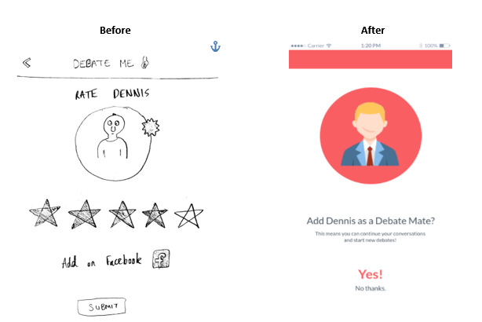

**Design decision for rating system:**

The rating system of Debate me was modified in the final product, users now would have the option to add their opponent to their favorite’s list, instead of the rating the opponent by the amount of starts. This change was made due to the user’s tests, as users were confused whether they were rating them based on the quality of the debate or whether they liked that person. Another reason changes were made to the rating system were also due to the fact that in the early stages when the application would be released, there wouldn’t be many users rate.

# Theory **Emotional Design:** We want users to have a positive experience using our app. The goal is to form friendships and improve real life skills such as communication. The design is light and easy coloured to be attractive and inviting to users. We have designed features that separate a little from the “debate” aspect and also into the “discussion” component where users are given the freedom to branch off, go off topic and have a good time. An argument can be made that the discussion component leave just a simple chat system however, the app provides a platform for that initial contact phase for people that they don’t get in many other places.

**Awareness:**Users of Debate me will be aware of their surrounding and their community. The app provides a platform for them to meet people they had no idea existed within their community sharing the same interests.  
  
  
**Collaboration:**The group discuss feature allows users to meet in-person to discuss topics and form a community of debaters.

# Limitations

* Lack of development and coding skills and experience. The team mostly consisted of designers so it was very difficult to come up with a solid high fidelity prototype solution.
* Due to the restrictions posed by the Marvel app, a lot of the features are static and non clickable.
* There is a lack of legitimate academic research in the problem domain so majority of the project decisions are based off user research.
* Focusing more on the making friends through the app is a possible future element the team needs to consider.